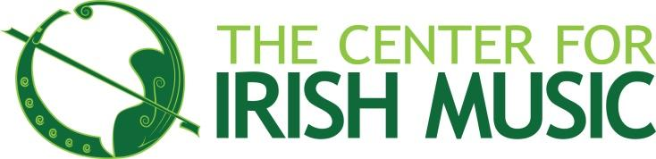

September 6, 2024

Welcome to the Center for Irish Music!

We’re thrilled to see so many first-time students from near and far this fall, and we look forward to getting to know you. Since the Center for Irish Music first opened in 2004, we’ve grown from having just a handful of students to teaching over 430 student musicians of every age and skill level each year, all of whom we encourage to be active players in the Twin Cities’ thriving Irish music scene.

This year is a significant milestone for CIM as it is our **20th Anniversary year**! Our Expansion & Improvement leasehold improvement project was completed in July 2024 with two bright signs hanging on the south wall of the Celtic Junction Arts Center. We are enjoying our doubled our square footage (now 4000 square feet), and new classrooms. The addition of two large classrooms, including the Scanlan Music Hall, allows us to offer more classes than ever before, and gives us scheduling flexibility that we have needed for years

Here are a few “trad tips” that will make your lessons, sessions, and CIM time even more enjoyable.

**Don’t be shy:** The Center for Irish Music, and the wider community at the Celtic Junction Arts Center (CJAC) are friendly places! We recommend taking some time to get to know instructors and fellow students in our bustling lobbies, reach out to us via email or on social media, or introduce yourself at one of our events.

**Listen closely:** Irish music is an aural tradition, and we encourage you to augment the recordings from your lessons by checking out our Common Repertoire at [www.centerforirishmusic.org/resources](http://www.centerforirishmusic.org/resources). You will find pages of great digital resources and audio downloads of tunes for students of all levels. For even more inspiration, check out some of the amazing concerts put on by the CJAC - you can find them at [www.celticjunction.org](http://www.celticjunction.org). CJAC concerts are FREE for kids under 18!

**Take in a session:** You’re all very welcome to come and listen to one of the sessions that CIM community members take part in. Check out the list of sessions on our [Twin Cities Irish Music Session](https://www.centerforirishmusic.org/twin-cities-irish-sessions/) blog post under the music resources section on our website.

**Pitch in:** CIM is a thriving community music school thanks in large part to our generous community of supporters, including more than 160 volunteers each year. Donations from our community pay for nearly 40% of our annual operations, providing financial aid on tuition, low-cost instrument rentals, and outreach performances around the Twin Cities. You can help us “hand down the tradition” by signing up to volunteer, donating to our annual fund, or by attending Éigse, our annual fundraising “gaela”.

**Clap along:** If you’re new here, you’ll notice we do recitals a little differently at the Center for Irish Music—we make them fun and casual! Mark your calendars for our Youth Recitals and Adult Student Open Mic night in the fall and spring terms, where clapping, stomping, and hooting are encouraged.

Thank you for being part of the CIM community!

Sincerely,

Norah Rendell Dave McKenna  
CIM Executive Artistic Director CIM Board President

**HOW TO STAY CONNECTED AT THE CENTER FOR IRISH MUSIC**

There are lots of things going on around here! Our staff and instructors do their best to keep students in the loop, but here are a few things you can do to keep yourself connected.

1. **Touch base with your instructor.** Take a few minutes at least once/month to talk to your instructor and ask what you can do to enrich you, or your child’s learning process. Get to know other CIM families and share ideas & experiences.
2. **Read your emails from CIM.** Add nrendell@centerforirishmusic.org, lgaetgaeow@centerforirishmusic.org, newsletter@centerforirishmusic.org and admin@centerforirishmusic.org to your address list.
3. **Read CIM’s** [monthly newsletter](http://www.centerforirishmusic.org/students/newsletter/)**.** Aimed at a general list of supporters, our newsletter is a great way to read about community events & concerts, hear from our director, learn about a new Irish traditional album, and find ways to help CIM raise critical funds. Parents, grandparents, aunts, and uncles who wish to keep abreast of Irish music happenings are encouraged to sign up for the newsletter on CIM’s home page.
4. **Log in to your student portal.** You can view your account balance, make payments, and check the dates and times of lessons and classes for each family member. Go to the “My Activities” tab to view your family’s schedule! Direct login questions to Lily Gaetgaeow.
5. **Follow the Center for Irish Music** on [Facebook](https://www.facebook.com/thecenterforirishmusic/) and [Instagram](https://www.instagram.com/centerforirishmusic/?hl=en). We are active on social media and like to interact with our students online!
6. Check the [**Classes & Events page**](https://www.centerforirishmusic.org/calendar/) **and** [**News page**](https://www.centerforirishmusic.org/news/) of our website for updates regularly!
7. **Volunteer!** As a nonprofit music school, we rely on volunteer support to make our work happen. Volunteering is also a great way to meet fellow students and families while giving back to the CIM. We hope you’ll reach out to Aja (**amccullough@centerforirishmusic.org**) if you’re interested in helping!

**CIM STAFF**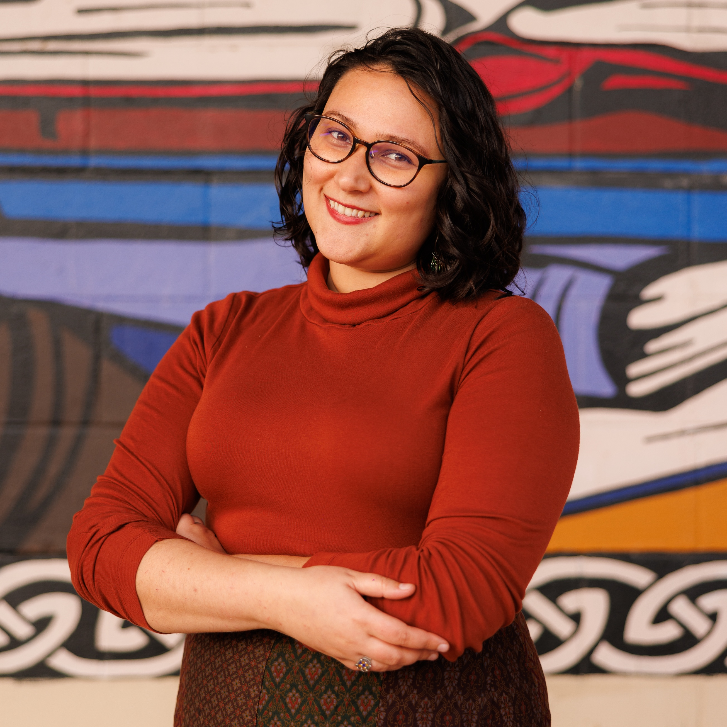

For general inquiries regarding lesson schedules, group classes, instrument rentals, or help with your student portal, contact:  
**Lily Gaetgaeow, Registration Coordinator & Administrative Associate**  
lgaetgaeow@centerforirishmusic.org or admin@centerforirishmusic.org

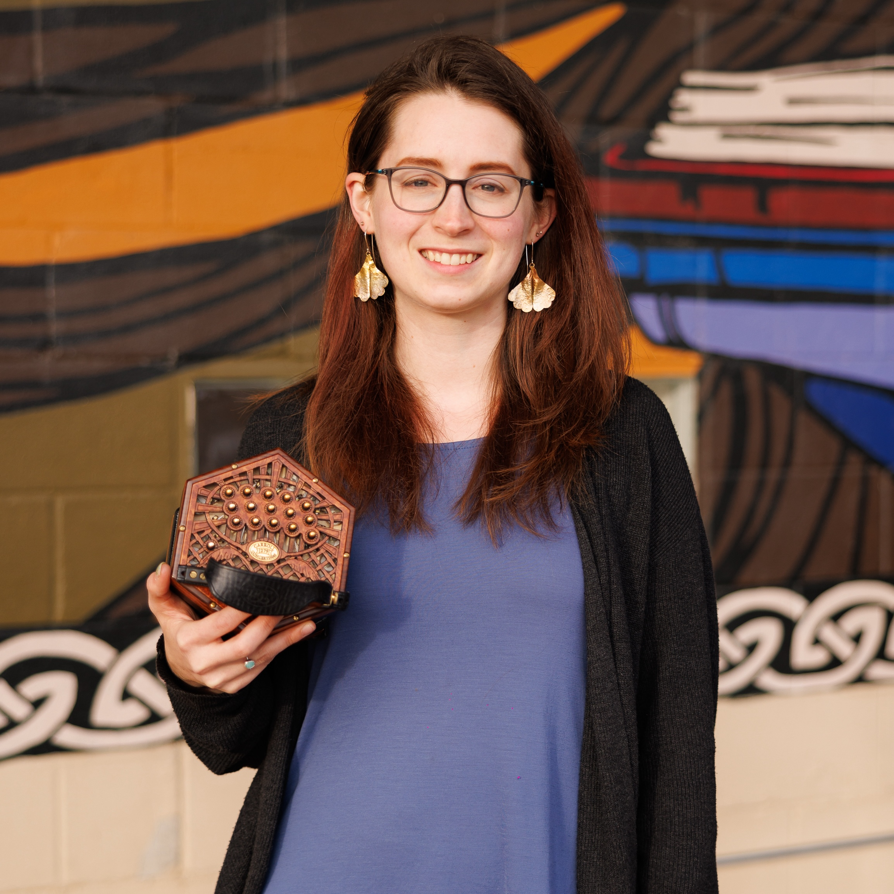

For inquiries regarding your account, billing and payment, contact:

**Mattie Ernst | Accountant**  
mernst@centerforirishmusic.org

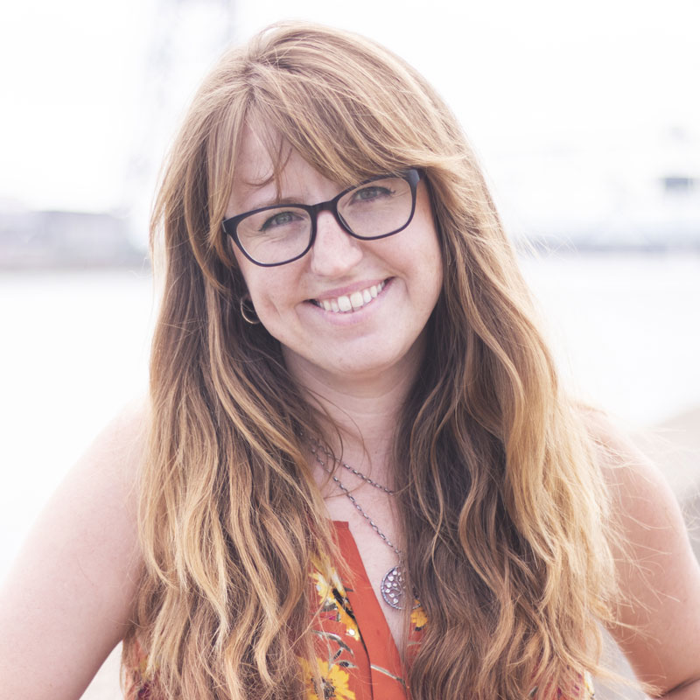

For inquiries related to volunteering, events, items for the CIM newsletter or website, contact:

**Aja McCullough | Events & Communications Coordinator**  
amccullough@centerforirishmusic.org

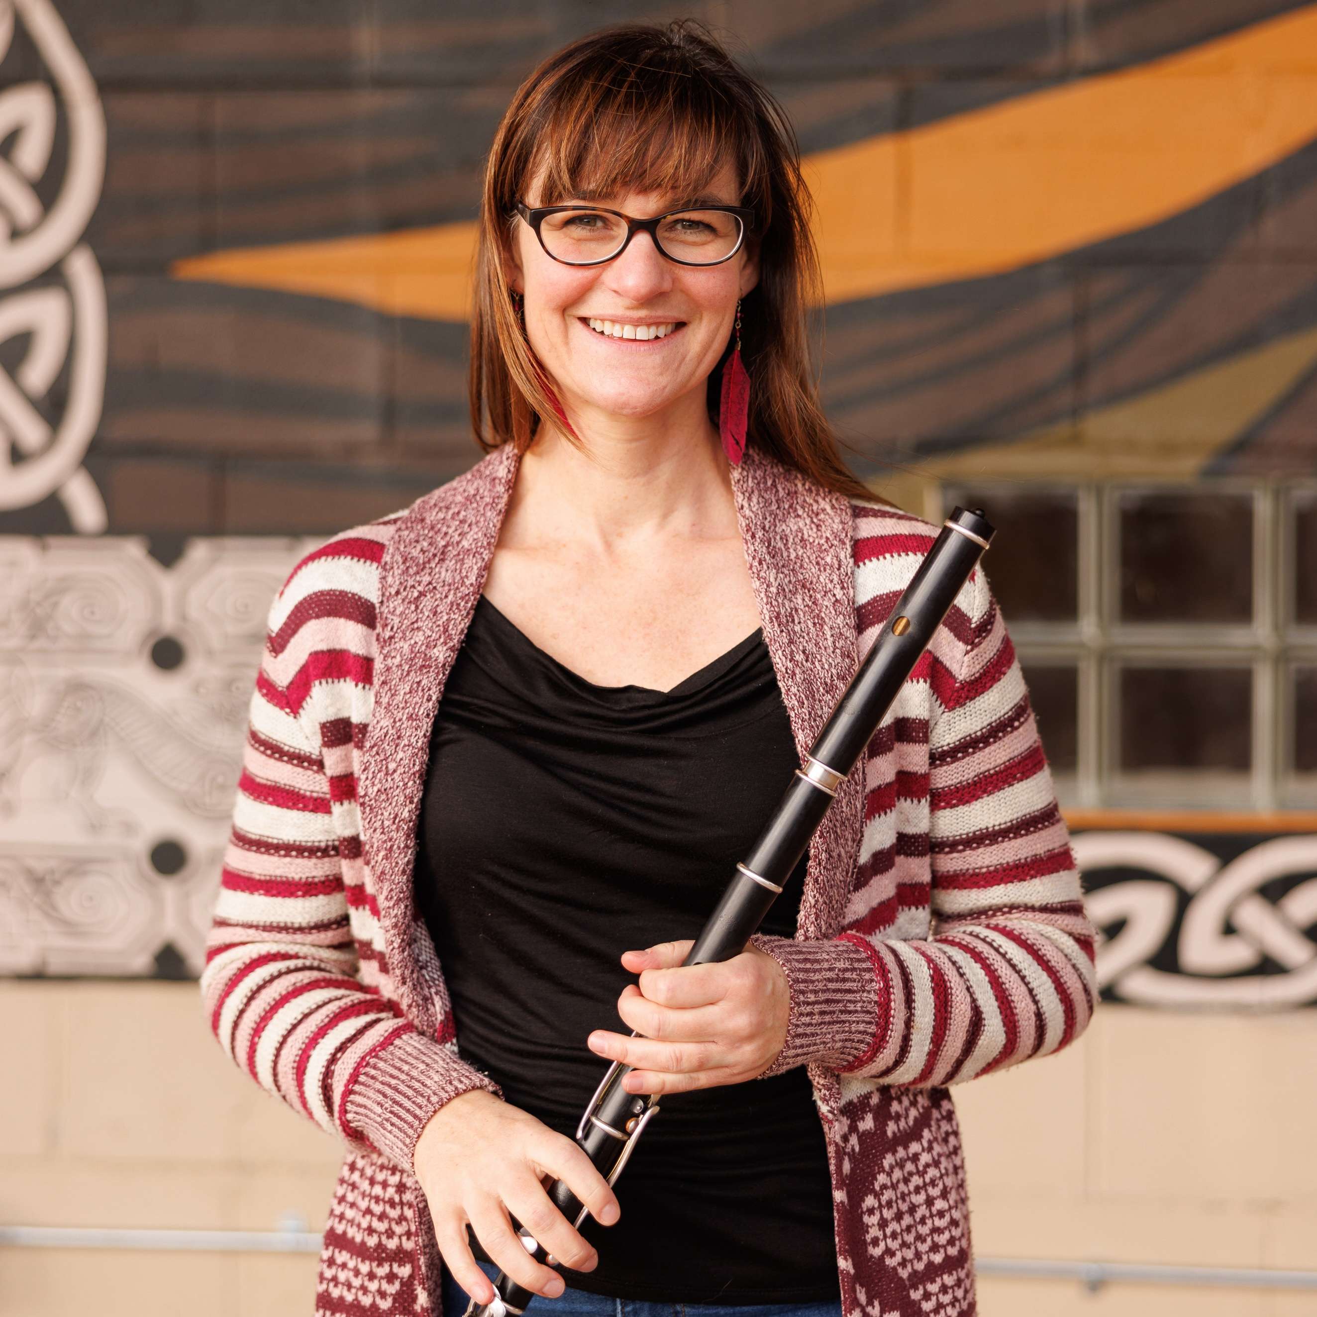

For inquiries regarding programming, class ideas, donations or performances, contact:

**Norah Rendell | Executive Artistic Director**  
nrendell@centerforirishmusic.org

**INSTRUCTORS**

CIM instructors can be contacted on their CIM email accounts (first initial of first name + full last name + @centerforirishmusic.org, e.g. Cory Froehlich can be reached at [cfroehlich@centerforirishmusic.org](mailto:cfroehlich@centerforirishmusic.org)).

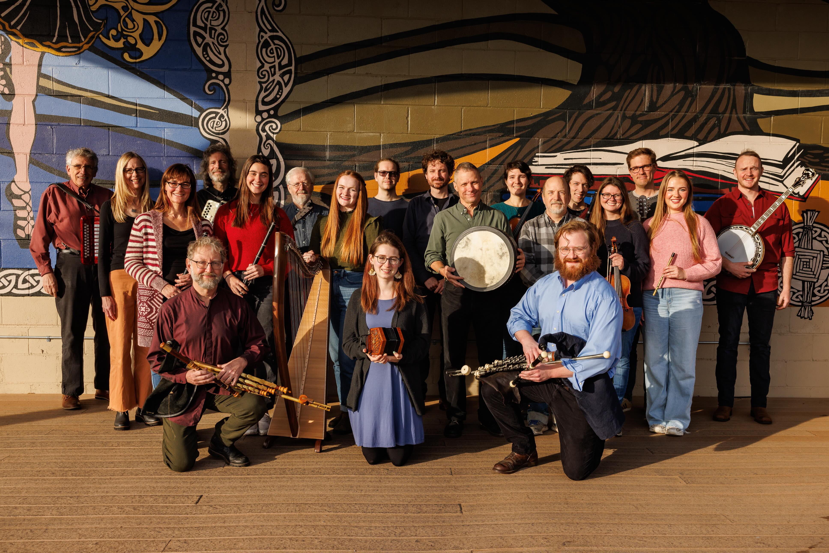

**WHAT’S HAPPENING HERE AT THE CELTIC JUNCTION ARTS CENTER?**

The **Center for Irish Music** moved from the Wellstone Center to our permanent space inside the Celtic Junction in 2009. Under the ownership and stewardship of Natalie & Cormac O’Shea—major Irish music supporters themselves—the building has become a home-away-from-home for many thriving Irish arts organizations. We hope you’ll take a moment to learn about the amazing independent organizations and businesses that share space, students, volunteers, passions—even teachers! Here’s an explanation of who’s who in this building:

|  |  |
| --- | --- |
| image15.png | **Center for Irish Music (CIM)** - the 501c3 nonprofit traditional music school where you’re registered for classes and lessons! CIM hosts a number of activities and presents two large events annually, the **Minnesota Irish Music Weekend** (June 5-8), the premier traditional Irish music festival in the Midwest and **Éigse CIM, A Gaela Event** (February 22), our annual fundraising dinner, auction & concert. |
| image4.png | **O’Shea Irish Dance (OID)** - Directed by original Riverdance cast member Cormac O’Sé, OID is a world-class competitive dance school that also presents professional dance & music shows at Christmas and St. Patrick’s Day. CIM and OID share lots of students & families. |
| image2.png | **Celtic Junction Arts Center (CJAC)** is the nonprofit branch of the Celtic Junction. Year-round it hosts classes in its beautiful Eoin McKiernan library, curates a series of incredible concerts (youth 18 and under attend for free), and promotes education & outreach as a cultural center. To find out more, join their mailing list! |
| image14.png | **Eoin McKiernan Library (EML - part of CJAC)** is an Irish-focused library with more than 1500 Irish music CDs, ongoing exhibitions and archives of local Irish community history (photos, recordings, etc.) and over 5000 books spanning Irish history, literature, language, art, and music. A part of CJAC, it gets its own spot here because the library director is one of our longtime instructors, Brian Miller. They have an incredible music collection you should check out! |
| image20.png | **Irish Fair of Minnesota** - a nonprofit organization dedicated to promoting and celebrating Irish culture and the community with a large festival on Harriet Island on the 2nd weekend in August. (CIM is always involved in the Irish Fair with a booth, performances etc.) |

OTHER TWIN CITIES IRISH CULTURAL ORGANIZATIONS

**Irish Arts Minnesota (iam)** - Your go-to source for info on all Irish dance schools, musicians, gig listing and resources. The IMDA publishes a monthly newsletter, provides educational grants, and hosts family-friendly events at the Landmark Center for St. Patrick’s Day. They also present the annual iam Honors Event. Become a member!

**Gaeltacht Minnesota** - For three decades, Gaeltacht Minnesota has supported the Irish language by providing its Monday evenings lessons free of charge.

**Irish On Grand** - A one-stop shop for Irish imports, including CDs, food, clothing, and decor.

**Brian Boru Irish Pipe Band** - A local fixture in parades, celebrations, dances, and festivals.

**Traditional Singers Club -** Celebrating unaccompanied song from all traditions. The club hosts monthly song sessions on the last Sunday of the month from 3-5pm.

**Great Northern Irish Piper’s Club (GNIPC) -** Dedicated to the national instrument of Ireland, the uilleann pipes.

**Twin Cities Robert Emmet’s Hurling Club** - A nonprofit dedicated to promoting and developing the amateur sport of hurling in Minnesota. They are offering youth classes on Sundays.

**Irish Network Minnesota** - a 501(c)(6) organization serving as a social, cultural and professional hub that connects the dots between the Irish Community and friends of Ireland in Minnesota and beyond.